**Test Cases for Tip Calculator**

**Test Case 1:**

Bill :- 1000

Tip % :- 10

Number of People :- 2

**Expected output Actual output**

Tip Per Person :- 50.00 Tip Per Person :- 50.00

Total Per Person :- 550.00 Total Per Person :- 550.00

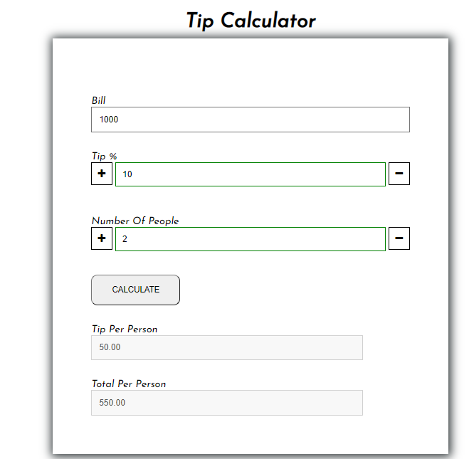

**Test Case 2:**

Bill :- 21ef33

Tip % :- 12

Number of People :- 12

**Expected output Actual output**

Tip Per Person :- NaN Tip Per Person :- NaN

Total Per Person :- NaN Total Per Person :- NaN

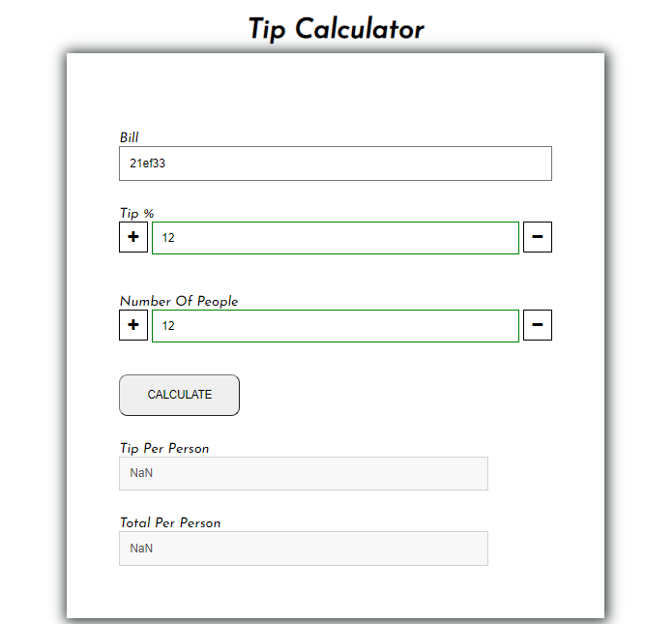

**Test Case 3:**

Bill :- 0102

Tip % :- 2

Number of People :- 2

**Expected output Actual output**

Tip Per Person :- 1.02 Tip Per Person :- 1.02

Total Per Person :- 52.02 Total Per Person :- 52.02

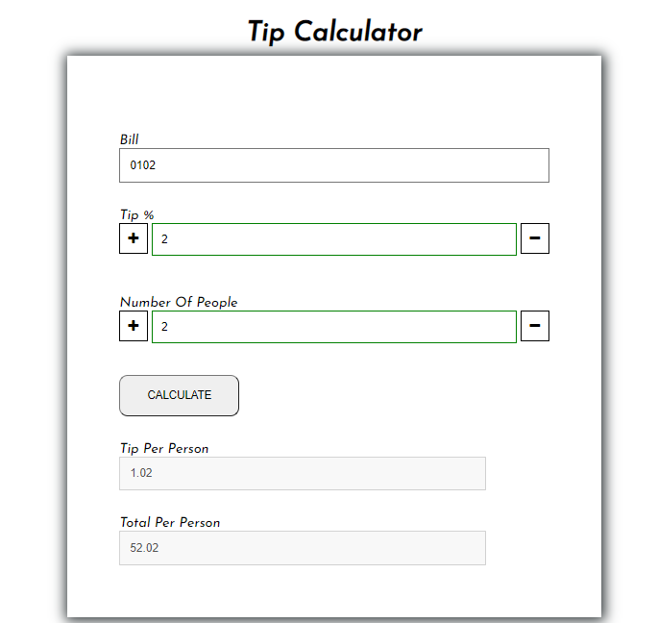

**Test Case 4:**

Bill :- 100

Tip % :- 0

Number of People :- 4

**Expected output Actual output**

Tip Per Person :- 0.00 Tip Per Person :- 0.00

Total Per Person :- 25.00 Total Per Person :- 25.00

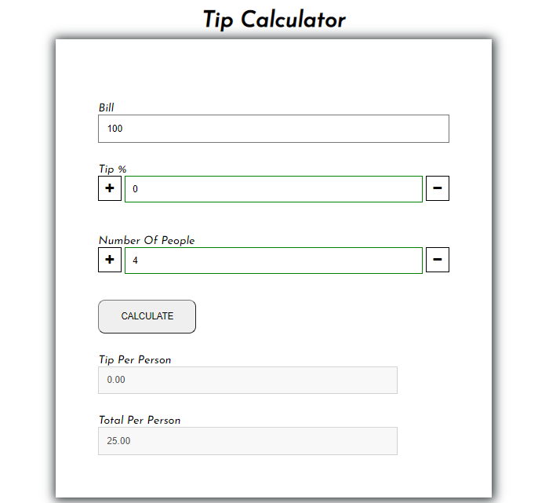

**Test Case 5:**

Bill :- 1000

Tip % :- 100

Number of People :- 4

**Expected output Actual output**

Tip Per Person :- 250.00 Tip Per Person :- 250.00

Total Per Person :- 500.00 Total Per Person :- 500.00

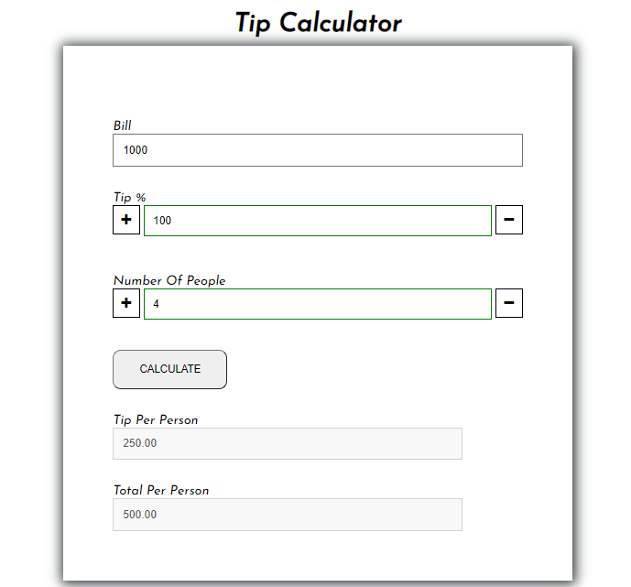

**Test Case 6 :**

Bill :- 10000

Tip % :- 100

Number of People :- 19

**Expected output Actual output**

Tip Per Person :- 50.00 Tip Per Person :- 50.00

Total Per Person :- 550.00 Total Per Person :- 550.00

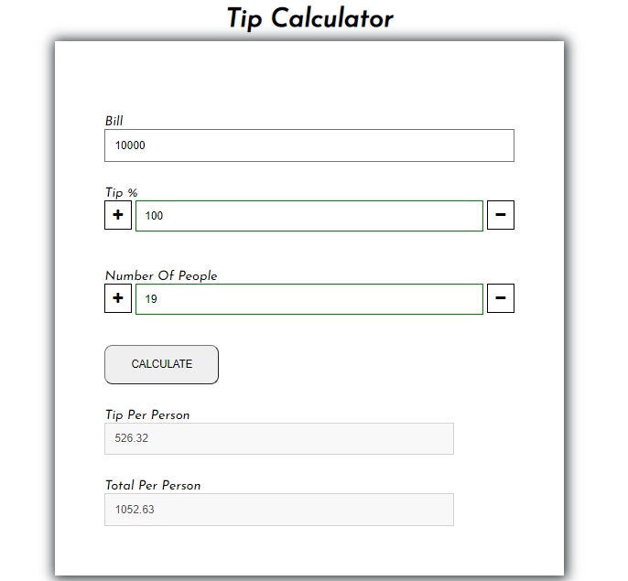

**Test Case 7:**

Bill :- 100000

Tip % :- 2

Number of People :- 100

**Expected output Actual output**

Tip Per Person :- 20.00 Tip Per Person :- 20.00

Total Per Person :- 1020.00 Total Per Person :- 1020.00

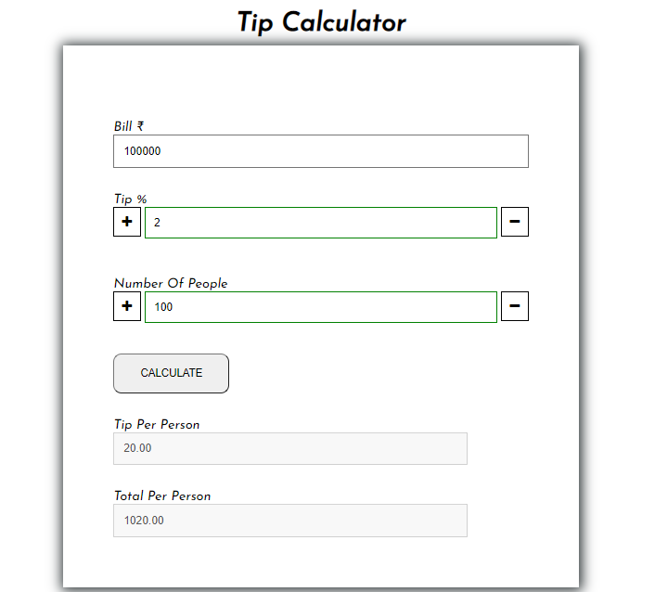

**Test Case 8:**

Bill :- 10256.75

Tip % :- 23

Number of People :- 7

**Expected output Actual output**

Tip Per Person :- 337.01 Tip Per Person :- 337.01

Total Per Person :-1802.26 Total Per Person :- 1802.26

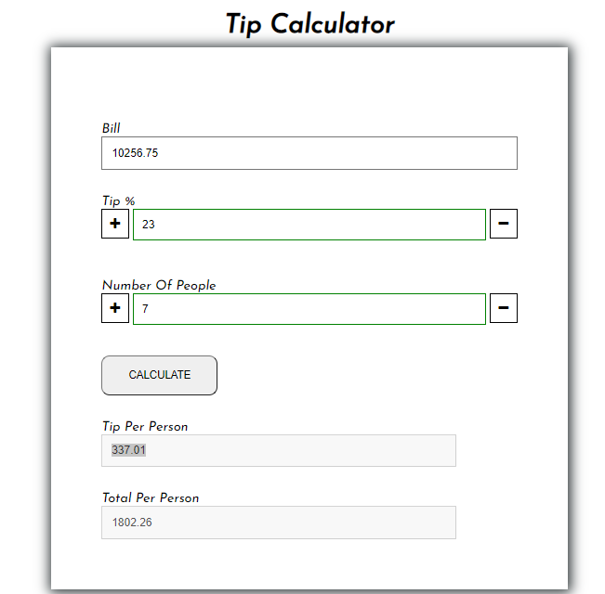

**Test Case 9:**

Bill :-2600

Tip % :- 10

Number of People :- 7

**Expected output Actual output**

Tip Per Person :- 37.14 Tip Per Person :- 37.14

Total Per Person :- 408.57 Total Per Person :- 408.57

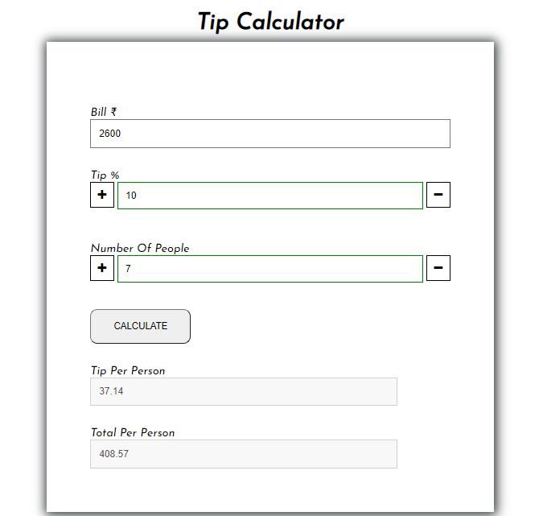

**Test Case 10 :**

Bill :- 7865

Tip % :- 4

Number of People :- 8

**Expected output Actual output**

Tip Per Person :- 39.33 Tip Per Person :- 39.33

Total Per Person :- 1022.45 Total Per Person :- 1022.45

